Summary  
In the project a program was developed to model shock wave propagation through a 1D semi-infinite solid. Errors with the calculation of initial internal energy, modification of the equation of state, and a syntactical error in a particular line lead to incorrect calculation of the relevant parameters of the model. These errors were corrected and the revised model properly resolves the behavior of the system verified by the results of Ward [1]. This update is intended to modify and correct the presentation of results on 5/1.  
  
Results  
Identical initial conditions were used as Ward and the simulation is iterated until t=50 us. Figure 1 presents the revised model results with the same plots from Ward for comparison. The results agree fairly closely, with ~5% variation. Unsurprisingly Ward’s methods resolve the discontinuities better owing to his hybrid approach and dynamically enforced Courant number.

Both models resolve the shock wave better than the expansion fan. In the revised model’s case this is a result of the artificial viscosity introduced by the L-F flux scheme. Ward’s solution uses 101 points and C=0.95, in comparison to 1001 points and C=0.57 for the revised model.  
  
References

[1] The simulation of shock- and impact-driven flows with Mie-Gruneisen equations of state  
<http://thesis.library.caltech.edu/6211/1/ward_thesis.pdf>

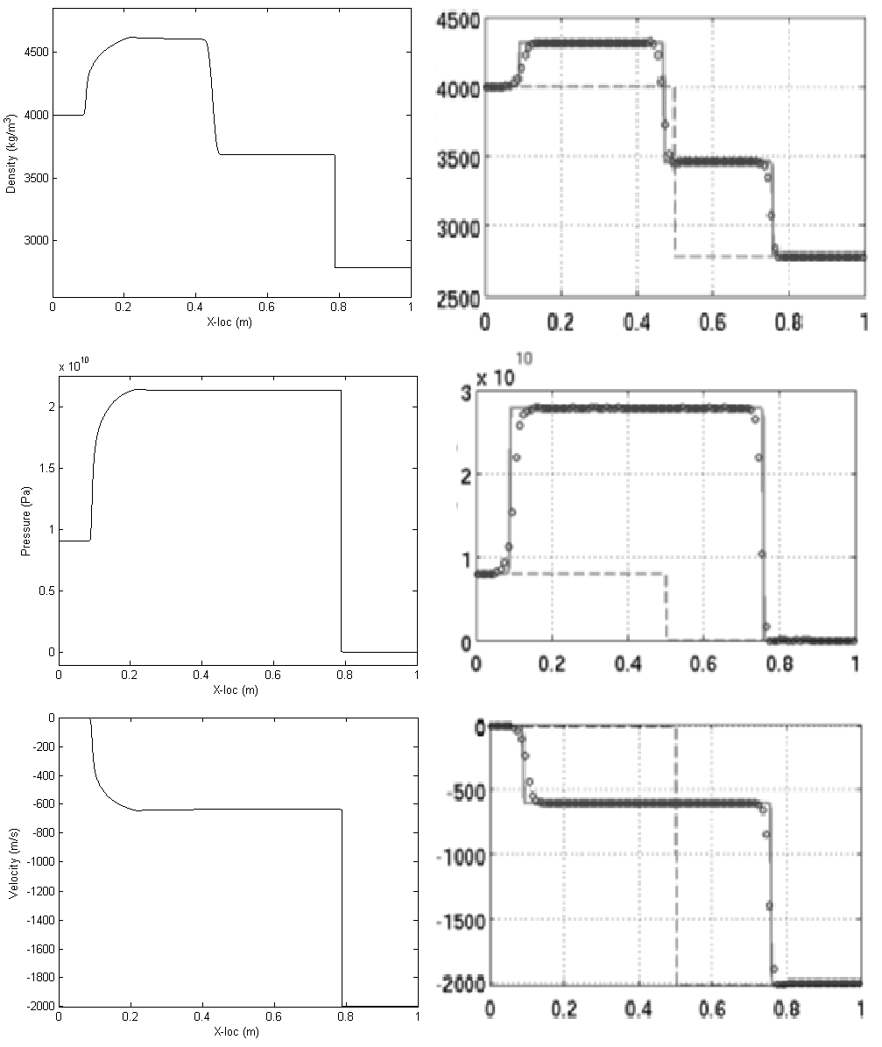

Figure 1: Comparison of revised model with results of Ward [1] pg 50

**Appendix A – Updated Program Code**

%%%%%%%%%%%%%%%%%%%%%%%%%%%%%%%%%%%%%%%%%%%%%%%%%%%%%%%%%%%%%%%%%%%%%%%%%%

%Josh Bevan 2013

%Num. Methods for PDEs, 22.520

%

%Solves shock wave propagation through a 1D solid

%

%Uses Mie-Gruneisen constitutive EoS to model compressive effects

%Uses Rankine-Hugoniot jump conditions to bridge shock discontinuity

%Uses Lax-Friedrich flux scheme to time-iterate conserved quantities

%Based on code by Anand Dhariya, UMich

%

%Theory heavily based on work by Geoffrey Ward, Caltech

%http://thesis.library.caltech.edu/6211/1/ward_thesis.pdf

%

%Limitations:

%-First-order approx for EoS limited to compressive states where rho>rho0

%If tensile effects need to be resolved try second-order Murnaghan isentrope

%(see Ward pg 8)

%-Artificial max density, singulatiry in linear shock relation(Ward pg 9)

%-Artificial minimum pressure (Ward pg 9)

clear;

clc;

close all;

%Model parameters

n=10001; %Number of grid points

L=1; %Length of domain

h=L/(n-1); %Spatial step size

CFL=0.57; %CFL number for stability

t_final=5000e-8; %Final time in sim (secs)

x=0:h:L;

%Material params

Material='Aluminum'

G= 76e9; %Shear Modulus (Pa)

rho0= 2785; %Density (kg/m^3)

Grun= 2.0; %Gruneisen parameter

Sigma= 1.338; %related to dK/dp uses linear assumption for Us to Up

specheat= 897; %Cv (J/kg K)

%Initial conditions

%Separated into left and right domains with x=0.5 dividing

p_l=-6.4e+10;

p_r=0;

rho_l=4000;

rho_r=rho0;

u_l=0;

u_r=-2000;

p(1:1:(n+1)/2)=p_l;

p((n+3)/2:1:n)=p_r;

rho(1:1:(n+1)/2)=rho_l;

rho((n+3)/2:1:n)=rho_r;

u(1:1:(n+1)/2)=u_l;

u((n+3)/2:1:n)=u_r;

T(1:n)= 0;

rho0v(1:n)=rho0;

e0v=specheat*T; %Undeformed internal energy

%Total internal Energy

E=e0v+0.5*p.*(1./rho0v-1./rho);%+0.5*u.^2; Kinetic energy should not be included, it is not internal energy

a=sqrt(G./rho); %Speed of sound

a0=sqrt(G/rho0);

dt=CFL*h/max(abs(u+a));

step=0;

%Time iteration

for t=dt:dt:t_final

%Define q & F matrix

q=[rho; rho.*u; rho.*E];

F=[rho.*u; rho.*u.^2+p; u.*(rho.*E+p)];

%Update q matrix and flow parameters

q(1:3,2:n-1)=0.5*(q(1:3,1+2:n)+q(1:3,1:n-2))-dt/(2*h)*(F(1:3,1+2:n)-F(1:3,1:n-2));

rho=q(1,1:n);

u=q(2,1:n)./rho(1:n);

E=q(3,1:n)./rho;

%Using linear shock speed model:

%Calculate pressure and energy along shock Hugoniot

xi= 1./rho0v-1./rho;

pH= a0^2*xi./(1./rho0v-Sigma*xi).^2;

eH= e0v+(pH/2).*xi;

%Calculate pressure based on first-order Mie-Gruneisen approx

p=pH+Grun*rho.*(E-eH);

step=step+1;

end

%Info for plotting

a=sqrt(G./rho); M=u./a;

s=specheat*log(rho./rho0); %Entropy, this is likely incorrect

Q=rho.*u; %Mass Flow rate per unit area

%------------------------------------------------------------------------%

offset=0.05;

subplot(231);plot(x,p,'k');xlabel('X-loc (m)');ylabel('Pressure (Pa)');ylim([min(p)-(offset)*max(p) (1+offset)*max(p)]);

%subplot(232);plot(x,s,'k');xlabel('X-loc (m)');ylabel('Entropy');ylim([min(s)-(offset)*max(s) (1+offset)*max(s)]);

subplot(233);plot(x,u,'k');xlabel('X-loc (m)');ylabel('Velocity (m/s)');ylim([min(u)-(offset)*max(u) (1+offset)*max(u)]);

subplot(234);plot(x,M,'k');xlabel('X-loc (m)');ylabel('Mach number');ylim([min(M)-(offset)*max(M) (1+offset)*max(M)]);subplot(235);plot(x,rho,'k');xlabel('X-loc (m)');ylabel('Density (kg/m^3)');ylim([min(rho)-(offset)*max(rho) (1+offset)*max(rho)]);

subplot(236);plot(x,Q,'k');xlabel('X-loc (m)');ylabel('Mass Flow (kg/m^2s)');ylim([min(Q)-(offset)*max(Q) (1+offset)*max(Q)]);

step